P.S. 108
The Philip J. Abinanti School
United in Excellence

Charles Sperrazza
Principal
Lori Solano Georgette Valente
Assistant Principal Assistant Principal _____________________________________________________________________________________________
August 24, 2020

Dear Parents/Guardians,

On behalf of the entire 11x108 staff, I am writing to thank you for your engagement in planning the reopening of our school for the 2020-2021 academic year. We especially appreciate all those that were able to join our Virtual Family Town Hall(s) on August 12th as these conversations provided us with important information and feedback.

I would like to inform you that our school has selected Model 1B. As you can see from the graphic below, Model 1B allows us to safely reopen the school building with two cohorts of in-person learning, plus a group of students whose family opted for full-time remote instruction. Each in-person cohort will have two consistent days of in-person instruction per week, plus an additional day every other Monday (see below).
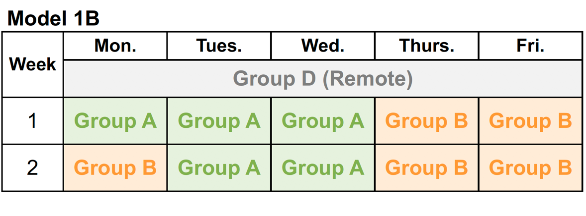

This week, you will receive additional communication assigning your child to their in-person learning cohort so that you can be aware of exactly which days your child will be coming into the school building. If you have any questions or concerns regarding your child’s cohort assignment, feel free to contact the school by emailing our parent coordinator Mrs. Giorgina Rodriguez@ GiRodriguez23@schools.nyc.gov.

Further information about the city’s reopening plans can be found by visiting the Department of Education website https://www.schools.nyc.gov/school-year-20-21/return-to-school-2020 or by dialing 311.

Sincerely,

Charles Sperrazza, Principal

